**CPE223 – Signals And Systems**



**Lab # 4**

**To Show the Response of Different System Classifications Using I/O Relationship In MATLAB.**

|  |  |
| --- | --- |
| **Name** | Muhammad Aizaz Arshad. |
| **Registration Number** | 088. |
| **Class** | FA18-BCE-A. |
| **Instructor’s Name** | Sir Umair Shafique. |

**Assessment**

|  |  |  |  |
| --- | --- | --- | --- |
| **Performance** |  |  | **Total** |
| **Results** |  |  |
| **Lab Report** |  |
| **Viva** |  |

**OBJECTIVES:**

To study and understand the working of Systems, explain the transfer of input signals into output signals, and to explain the system on the basis of number of inputs and output signals in which the system returns.

**METHODOLOGY:**

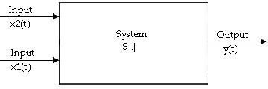There are two types of systems on the basis of input which are:

* Single input single output
* Multiple input signal output

There are two types of systems on the basis of output which include:

* single input multiple output
* multiple input multiple output

This lab made a throe intro to the output response of different systems using different MATLAB techniques. By giving multiple inputs to the system this lab made us learn how to calculate single output and also multiple outputs were given for finding multiple system responses. Again signals were plotted in time domain in the form of discrete and continuous and their range according to student’s roll number was given for computing output responses.

**In Lab Tasks:**

t = -5:0.1:5

x1 = heaviside(t);

x2 = 0.5 * heaviside(t);

y1 = (x1 + x2)

y2 = (x1 - x2)

subplot (3, 2, 1)

plot (t, y1)

subplot (3, 2, 2)

plot (t, y2)

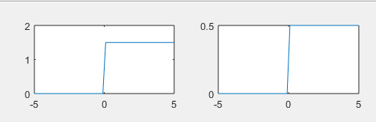

Task 2

t = 0:0.1:4;

x1 = heaviside(t) - heaviside(t-3);

x2 = t .* sin(t);

x3 = t .* cos(t);

y = x1 + x2 .* x3;

plot(t,y)

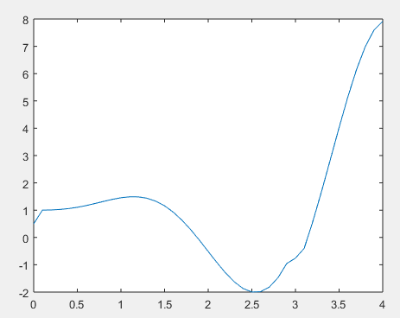

Task 3:

t = 0:0.1:5;

x1 = exp(2 .* t);

x2 = t .* exp(t);

x3 = cos(t);

y = x1 .* (x2+x3);

plot(t,y)

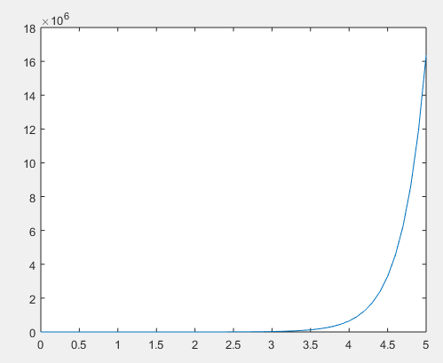

Task 4:

n = -10:10;

x1 = (n>=0);

x2 = n.^2;

y1 = x1 ./ x2;

y2 = x1 .* x2;

subplot (3,2,1)

plot(n, y1)

subplot(3,2,2)

plot(n, y2)

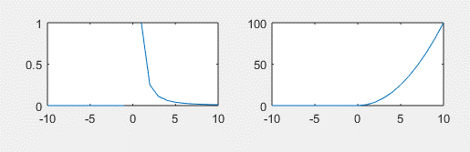

Task 5:

n = -10:10;

x1 = (n >= 0);

x2 = n .^ 2;

y1 = x1 ./ x2;

y2 = x1 .* x2;

subplot (3, 2, 1)

plot (n, y1)

subplot(3,2,2)

plot(n, y2)

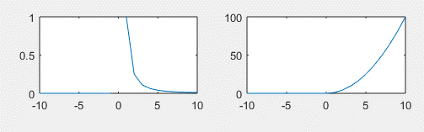

**CONCLUSION:**

Finally In this lab experiment we learnt the response of system by giving it single or multiple inputs by using MATLAB algorithms for sample of discrete and continuous time signals where different operations of addition and multiplication were applied on signals.